STATEMENT OF WORK

1

Assignment 1 – CSE 6329

Produce and Utilize a Personal Work Breakdown Structure (PWBS)

**What is the purpose of this assignment?**

This assignment will introduce you to some basic steps of project measurement:

* **planning** a project (identifying the work tasks that will be measured),
* **organizing** the project,
* **estimating** the cost of the project (in hours of work required),
* **tracking progress**, using measurement,
* **reporting progress**, using earned value and burn charts, and
* **using a spreadsheet** for the above activities.

In particular, you will learn how to use a **work breakdown structure** to record your plan and how to use **burndown charts**, **burnup charts** and **earned value** as tracking mechanisms. You will also be introduced to the concepts of

* making an estimate,
* tracking against that estimate,
* using the estimate to plan your work, and
* making better estimates in the future.

For this assignment, your “project” is **taking this course** and your tool for planning, organizing, estimating, tracking and reporting is a “personal work breakdown structure” (PWBS).

**What is a PWBS?**

The PWBS or **Personal Work Breakdown Structure** is a Microsoft Excel® workbook that shows your plan for taking the course, the time spent each week, and the work completed (earned) each week. A template is provided as a starting point, but you must modify that template as you develop your estimates and plans. You will deliver the PWBS at least **three** times:

1. For class session #2 you will deliver an initial DRAFT of the PWBS, showing your plan for taking the course and the work performed during the first week of the course. See **deliverables** (below) for the specific file naming convention. The instructor and grader(s) will evaluate your draft and give you comments and suggestions. This version will not receive a grade.
2. For class session #4, you will deliver an INTERIM version of the PWBS, showing any revisions to your plan and the work performed during the first three weeks of the course. **This interim version will receive a grade that counts as part of your final course grade.**  Note: revisions to your plan typically result from two things – comments received from the instructor or grader for your draft PWBS and changes made because of teaming.
   * If your interim submission is not sufficient, we may suggest that you make corrections and check with the grader or instructor to make sure you are doing it correctly.
3. At the end of the semester, after the last class, you will turn in the FINAL version of the PWBS. **This final version will receive a grade that counts toward your final course grade.**

**So what exactly must I do for Assignment 1?**

For assignment 1, you will **make a plan** for taking this course, **document that plan** in your PWBS, and **record the actual time spent** on the course (up to the time when you submit the assignment). The first two of these steps will occur with your DRAFT version and the third step will occur with each version.

To make and document your plan, you will examine all course assignments and figure out what tasks you will perform as you take this course. Then you will modify the template to put those tasks into the spreadsheet. In other words, you will provide the details of your plan. You will then estimate how much effort it takes to do each of the tasks and record that in the PWBS.

To track progress, you will keep track of how much time you spend on each course assignment and use the PWBS to record the time spent. For the DRAFT version, you will only record the time spent during the first week of the course. For the INTERIM version, you will record the time spent during the first three weeks of the course and for the FIMAL version you will record all time spent on the course. If you are teaming with another student, each of you should have their own PWBS, but you may want to collaborate to identify the tasks.

**What happens after I turn in the DRAFT PWBS?**

First of all, you should make time to study the PWBS spreadsheet and understand each formula and how each graph is created. There may be questions on midterm or final exams about the spreadsheet.

Secondly, you should pay close attention to any comments made by the grader or instructor when they evaluate your DRAFT PWBS. You may need to change your plan as a result of this. You may also decide to change your plan somewhat because you have selected a team mate and the two of you have decided how to allocate the work between you. For example, instead of both of you performing a task, you may decide to split it into two parts or may decide to have one of you perform the task and the other review what was done. Make sure that both of you know how to perform the task, however, as there may be a question on an exam about this.

Each week during the semester, as you work on the various assignments, you will record your **actual** **hours worked**, **estimated hours remaining** and **hours earned** (these are separate things) in the PWBS so as to keep track of your progress as you go through the semester. At the end of week 3 (the day of lecture 4) you will turn in the INTERIM PWBS and at the end of the semester you will turn in the FINAL PWBS. If you do this properly, it will help you understand your progress and allocate your time so you can complete the course assignments on time.

**Work to be Performed:**

**Week 1:**

1. **Construct the DRAFT PWBS.** Using the template for Assignment 1 (see below), prepare a ***Personal Work Breakdown Structure*** that describes the detailed work tasks *you* will do for this course (all assignments).
2. **Estimate the time required for each task** and record that information in the PWBS.
3. **Record *Actual Hours Worked***, ***Estimated Hours Remaining*** and ***Hours Earned*** for the first week of the course.
4. **Submit the DRAFT PWBS for review (at the end of week 1 - midnight on the day of the second class session).** See **Deliverables** (below) for the required file name.

**Weeks 2-3:**

1. **Continue to record *Actual Hours Worked***, ***Estimated Hours Remaining*** and ***Hours Earned*.** Continue recording all of these each week. You should also examine the various graphs (charts) to track your progress. Finally, you should study the PWBS spreadsheet so you understand each formula and how each graph is produced.
2. **Submit the INTERIM PWBS (at the end of week 3 – midnight on the day of the fourth class session).** See **Deliverables** (below) for the required file name.

**Weeks 4-n:** (until the end of the course)

1. **Continue to record *Actual Hours Worked***, ***Estimated Hours Remaining*** and ***Hours Earned*.** Continue recording all of these each week as you go through the course. You should also examine the various graphs (charts) to track your progress.
2. **Submit the FINAL PWBS (at the end of the course).** See **Deliverables** (below) for the required file name.

**Note:**the template for your PWBS has the following file name: *“***A1 CSE 6329 2017fa PWBS template.xlsx”.** This can be found on the course blackboard site under **Assignment 1.**

See **Appendix A** and the template for details on the structure of the PWBS workbook and what you are to do with it.

Note: as you do the various assignments for the course, you will record the hours of work performed each week in the PWBS, as well as the estimated hours remaining (which will usually change a little each week as you revise your estimates of how long it will take to do things) and hours earned. (Hours are earned when you complete a task.) Your progress will be displayed in the **Burn Down Chart, Burn Up Chart** and **Earned Value Graphs**. You should plan to use these charts to track your progress. If the charts do not make sense, see the instructor or a grader to straighten things out. If you don’t have correct graphs or are not recording your hours correctly, you will lose credit on the INTERIM and FINAL version of the PWBS. Moreover, the longer you wait the harder it will be to accurately correct them. Furthermore, you will lose the benefit of having these graphs to help you manage your time.

At the end of the semester, you will record the hours spent and earned for the final week of the course and turn in the final PWBS along with your other assignments that are due at that time.

**Deliverables**:

**Week 1: Draft PWBS** (result of Appendix A steps a-d).

* Change the template file name to replace “**Template**” with “**last first**” where “**last**” is your last or surname and “**first**” is your first or given name. Also add the word “**DRAFT**” to the file name to distinguish it from the interim or final version. In other words, what you submit will have this file name:
  + - * “**A1 CSE 6329 2017fa DRAFT PWBS last first.xlsx**”
* The grader or instructor will send it back with comments and suggestions

**Week 3: Interim PWBS** (result of Appendix A steps a-f for first three weeks).

* Submit your INTERIM PWBS. This version will count 5% of your course grade. The file name will be:
  + - * “**A1 CSE 6329 2017fa INTERIM PWBS last first.xlsx**”

**Week 16: Final PWBS** (result of Appendix A steps a-f for entire course).

* Submit your FINAL PWBS. This version will count 5% of your course grade. The file name will be:
  + “**A1 CSE 6329 2017fa FINAL PWBS last first.xlsx**”

**Note**: All versions of the PWBS must be **Excel®** documents, created by modifying the *“***A1 CSE 6329 2017fa PWBS template.xlsx**” file in accordance with the process described in Appendix A of this SOW.

**Formatting rules for deliverables:**

Your name must appear in three places:

* 1. In the file name, as described above,
  2. On the cover sheet (first worksheet in the template), and
  3. At the top of ***the third*** worksheet (put your name where it says  ).

(I have a collection of WBSs, worksheets and graphs from previous students who forgot to put their names on them. I don’t know which is which!)

#### APPENDIX A

**PREPARATION of PERSONAL WORK BREAKDOWN STRUCTURE**

for

Recording and Tracking Student Effort

in

Completing the CSE 6329 Course Assignments

(Use these instructions to help you better understand how to use the template)

Note: it may be helpful to open and examine the template while looking at the following information.

The Personal Work Breakdown Structure is a tool used to help you estimate and track your effort in doing the assignments for this course. It is implemented as a Microsoft Excel® workbook containing five worksheets (tabs at bottom):

1. **Cover Sheet** [where you provide your name and other information. May be used by instructor/grader to give you comments.]
2. **Instructions for Recording Weekly Hours Worked and Earned**
3. **WBS** - Work Breakdown Structure worksheet (Figure 1).
4. **Burn Charts** worksheet
5. **Earned Value Graphs** worksheet

The third tab is the WBS (see Figure 1). This is where you will spend most of your time. It shows all work you are supposed to do for the course and your progress in completing that work. It includes your initial estimate and your final actual values for the hours of work you personally spend (your personal effort) to complete the course assignments. When complete, it should take approximately 3-5 pages if printed.



…



Figure 1 - WBS Template (the figure above shows a template from a previous course offering. The template for this semester may be slightly different. This semester’s template also has the correct dates and such for the current semester.)

The column named “**WBS**” contains your work breakdown structure and, to the left of that, there is information on your overall progress. The section on the right (“**Actual Hours Worked and Earned**”) is where you record your weekly progress (actual hours worked) so you can track your effort throughout the semester and continuously evaluate progress.

The burn charts and earned value charts worksheets show, graphically, how your are progressing. You should look at these each week to see how you are doing relative to your plan. If you do things correctly, these charts will be generated automatically by the template.

A template for this workbook is provided with the course materials for assignment 1. However you must modify that template to fit your specific plan for the course. The information below explains how each of the parts is organized. This will help you understand what to modify and how to do it.

***Note on spreadsheet template*:**

The template is color coded as follows:

**white –** *cells you may change*. In most cases, cells with a white background are cells where you may be expected to fill in numbers or other information. In some cases, the template already contains sample values, which you may change.

For example, here is an excerpt from the WBS portion of the worksheet:

|  |  |  |  |  |  |  |  |
| --- | --- | --- | --- | --- | --- | --- | --- |
|  | Read and Analyze A1 SOW for PWBS | | |  |  |  |  |
|  |  | List tasks to be performed |  |  |  |  |  |
|  |  | Estimate hours required for each task | |  |  |  |  |
|  |  | Break into smaller sub-tasks as required | |  |  |  |  |

In the above, the part on the left is where you list your tasks (your WBS) and the part on the right is where you enter the actual hours worked on each task each week. Note that in some cases, when you enter a value in a white cell it will change color. The color change is a convenient way of noting which cells you have entered data into. You may still change the data in such cells if you need to.

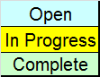**yellow –** *cells containing formulas*. Cells in yellow (and and occasionally other shades) contain formulas, most of which you will not normally change.

**Examples ->**

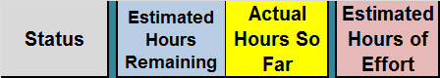**grey, blue, green, and other colors –** *labels and titles*. These are generally used for titles, labels and spacing. These are not normally changed.

**Examples ->**

Sometimes when you enter a value in a white cell, it will change color. It is OK to change the numbers in such cells.

**Also, there are a few cases where these cells contain formulas that you may need to adjust. That should only happen if you extend the length of the course, which you should only do with the instructor’s permission.**

## WBS Sheet

The initial (DRAFT) submission of the PWBS (assignment 1) is focused mainly on constructing the **WBS**, although you will also record data for the first week (in the first “**Actual Hours Worked and Earned**” column). Completing the PWBS involves five steps. **Note: it is helpful for you to complete steps a-d during the first week of the course – otherwise these instructions are not quite right with regard to recording hours spent and you will need to adjust accordingly.**

**Step a – Create your plan for the course -- WBS: Work to be Performed.**

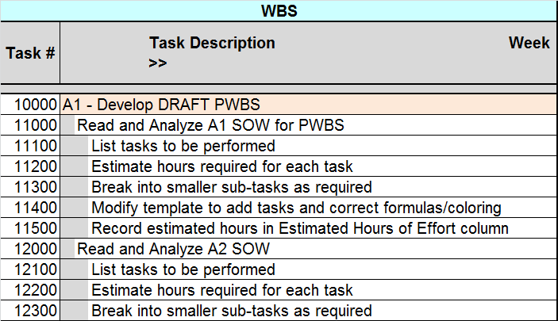In Step a, you create a list of the work tasks to be performed in doing all of the assignments for this course. This is divided into sections, corresponding to the individual assignments. (Developing the PWBS is part of assignment 1 or A1). Within each section, there is a list of work tasks needed to do the work for that assignment. Taken together, the sections describe all work you expect to do this semester in this course (except attending class). Note that the template (see figure above) shows a possible list of tasks and sub-tasks for assignment 1 – this is to help you get started. The template provides very little information for the remaining assignments – **you are expected to add many more rows to the spreadsheet for the later assignments** – a row for each work task – so that, by the time you have completed your plan, you will have a dozen or more work tasks for each assignment.

**How do you determine the work tasks?** You do it the way any software team would do so – you read the available information (in this case, the SOW for each assignment and perhaps some of the related materials), determine the work to be done for each assignment, figure out what work tasks you must perform to complete that work, and make a list of these tasks. See more below.

**Note 1:** each person will devise his or her own unique set of work tasks, based on how they plan to go about performing the work. If you are teamed with another student, you may collaborate with them to determine how you will divide up the work. But each of you will have your own set of work tasks and, even if many tasks are the same as those of your team-mate, your estimated hours should be different for some of the tasks.

**Note 2:** you should not simply divide the work and assign half of it to each student. Each student in a team is expected to know how to perform all tasks, and this may be tested on an exam. For very easy tasks, you may decide to assign the task to only one student. However, for more difficult tasks, each student should participate and thus each student should have a task line in their PWBS. In some cases, one student will perform the task and the other will review it to understand what was done. In other cases, each student will perform part of the task or they do it together. Thus, if you are on a team, your list of tasks may be similar to your teammate’s list but will not be identical.

**Task Numbers**

Each task has a unique task number (see the column labeled “**Task #**”). This is a five-digit integer. The purpose of the task number is twofold: 1) to uniquely identify each task and 2) to keep the tasks in the right order. In other words, if you were to select all the task rows and sort them on the **Task #** column, they would come out in the correct order.

The first digit in the task number is the assignment number and the remaining digits indicate which task (or subtask) it is – see Figure 1 or the template for examples. Task 10000 is the top level or parent task for assignment 1, task 11000 is the first sub-task for assignment 1 and so forth. You may use any numbering system that you find convenient. For example, if you break task 11000 into smaller, sub-tasks, you might number them 11100, 11200, and so forth. Just be sure that the first digit is the assignment number. **See Appendix B for some alternative task numbering systems, which may be needed for some situations.**

You may include the time spent studying for exams in the WBS, in which case you should come up with additional tasks and task numbers for this.

Note that in the template, subtasks are described one column to the right of their parent tasks and the cells to the left are greyed out. This makes it easier to see the hierarchy of tasks. When you insert new tasks into the WBS, you should make sure they are inserted at the correct position for their place in the hierarchy. To simplify this process, there are “spare” task rows for each possible task row you might wish to insert (“spares” are found at the bottom of the template). I strongly recommend using these “spare” task rows so as to get the formulas and formats correct.

For step “**a**” you will fill in the “tasks” (work to be performed), adding rows as you add new work tasks. If both members of a team will work on a task, you will often have similar lists of tasks for each student, but they should not be identical.

The template has a suggested list of tasks for a student working on assignment 1. The example in the template is only a suggestion for assignment 1 – you may change it as you see fit. Note especially that **the template is not complete for the later assignments**. It does not have enough work tasks or enough detail for assignments 2, 3, and 4. You may decide to modify or add tasks for assignment 1 or the exams as well. The template was provided simply to give you an idea of what is expected. You should examine all course assignments and determine all the work you will have to do. You must then plan that work (what tasks you will perform and when you will do them). That information will be used to construct a WBS that fits your specific plan. When done properly, a typical WBS is about 3-5 pages long.

A suggested process for constructing the task list for a specific assignment is as follows. I suggest doing this on paper until you have it the way you want it and then entering the actual task rows and estimates into the spreadsheet:

1. Look at the SOW for each assignment and find the list of high level tasks (**work to be performed**). Assign a PWBS sub-task for each of these tasks – these are the tasks you must perform for that assignment. For example, if it is assignment 2, the top-level task is 20000 and the sub-tasks would be 21000, 22000, 23000, etc.
2. Feel free to add more tasks if, after reading all materials for the assignment, you conclude that you will need to do things not mentioned as tasks in the SOW. If you are working with a teammate, you should work together on this (or you might work separately and then meet to compare and refine your lists of tasks).
3. When you estimate the time required for each sub-task (step b, below), note which of them have times greater 2 hours. For each of those you should consider breaking it into sub-sub-tasks. For example, if task 22000 is estimated to take 6 hours, you might break it into sub-sub-tasks 22100 (2 hours), 22200 (2.5 hours), 22300 (1.5 hours), and so forth. It is permitted to have some tasks that are longer than 2 hours, but most should not be this large. (If all of your tasks are exactly 2 hours, we will interpret this to mean you did not make a serious attempt to estimate the time for each task.)
4. Repeat this process on the lower-level tasks (breaking large tasks into smaller ones) until most of your lowest-level tasks have time estimates of 2 hours or less.
5. Occasionally you will break a task into smaller tasks because it makes sense to do so, even though it is already small enough. For example, if a 2 hour task will be done in three steps, you might break it down into 3 sub-tasks, corresponding to the three steps. These might be estimated to take 1 hour, 0.6 hours and 0.4 hours, respectively.
6. Be careful not to break tasks into too many small sub-tasks. If all of your bottom level sub-tasks are 0.1 hours in length, you probably have too many small sub-tasks.

* **When you are done with this, you should have an outline of the work to be done for the course.**

**Special Note for Teaming**: If you plan to team with another student, you need to discuss with your team-mate how you will allocate the work. There are two situations, depending on how soon your team is formed:

1. If you are able to team up before or shortly after the first day of class, I suggest you mutually agree on all the tasks that need to be done and decide how many hours each of you will spend on each of the tasks (don’t forget time to discuss/compare/review each other’s work). You will submit separate PWBSs that may have similar lists of tasks, but note that you and your team mate **should have different numbers of estimated and (later) actual hours for many of those tasks**. If your tasks and estimates are nearly all identical, it will indicate that you have not seriously planned/recorded your time.
2. If you do not team up until after the first week of class, you need to do a **replan** once you have chosen a team-mate. This means you each turn in a DRAFT PWBS for assignment 1 at the end of the first week. Later, you decide to team with someone, so you meet with your team-mate and come up with a new plan, which may result in new estimates and possibly new or modified tasks. In this case you should notify the grader and instructor that this is your intention and send in the revised PWBSs when you turn in the INTERIM PWBS. As with situation #1, above, you and your team-mate **should have different numbers of estimated and (later) actual hours for many of those tasks**.

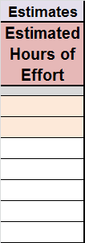**Step b: Estimated hours of effort (record to the left of the WBS).**

Estimate the effort, in hours, for each work task in your plan (if a task has sub-tasks, you should leave it blank – **only the lowest-level sub-tasks should have estimated hours of effort shown on the spreadsheet**). Place these initial estimates in two places:

1. the “**Estimated Hours of Effort**” column.
2. the “**Estimated Hours Remaining**” column (see step **c**).

If a task has an estimated time of more than 2 hours, consider breaking it into smaller sub-tasks. Note that you should make sure most of the lowest-level tasks are shorter than 2 hours and the higher-level tasks should have blank entries for estimated hours. Hours may be specified in tenths of an hour, and many tasks will likely take less than an hour to perform.

**Figure 2** (below) shows an example of how a portion of the spreadsheet might look after you have entered the estimated hours of effort for a portion of the second assignment. Note that the hours shown are simply an example, not a recommendation. You must estimate your own effort.



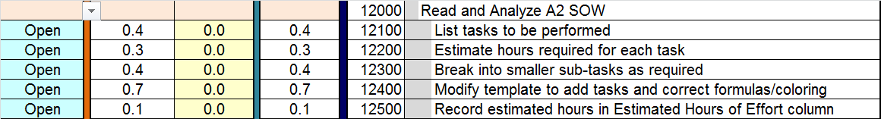

**Figure 2 – How the WBS might look after you have made your initial estimates.**

***Special note***: once you have completed the initial estimate (and made any corrections based on the grader’s or instructor’s suggestions) *you should never change the number in the* ***Estimated Hours of Effort*** *column*. This column becomes your permanent record of your initial estimate of the work to be done. However, you will change the number in the **Estimated Hours Remaining** column (see Step c).

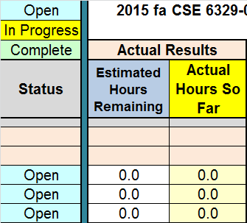**Step c: Actual Results (to the left of the estimates).**

Steps “**a**” and “**b**” are done for all tasks of all assignments (i.e., for the whole course) as part of the first week’s work on assignment 1. Your DRAFT PWBS, which is submitted at the end of the first week, should reflect this. Steps “**c**” through “**e**” are started in week 1, but updated each week throughout the semester.

The leftmost column shows the **Status** of each task. Initially, all tasks are in the “*Open*” status, which means none of them have been started. When you start work on a task, as indicated by a number recorded in a weekly “**Actual Hours Worked and Earned**” column (step **d**), the “**Actual Hours So Far**” will automatically be updated to indicate the total hours worked on the task so far (counting all work in all weeks) and the “**Status**” of the task will automatically be changed to “*In Progress*”. [Suggestion: look at the formula in the “**Actual Hours So Far**” column to figure out how it automatically computes the correct total.]

If you have started work on a task but have not finished it by the end of the week, enter the hours you actually worked on the task in the **Actual Hours Worked and Earned** column for that week (see step **d**, below).

Suppose you estimated a task would take 1.5 hours and you worked on it for 1 hour, but you now think it will take another hour to complete. This is the purpose of the “**Estimated Hours Remaining**” column. Once you have entered the hours actually worked for a task (1.0 for this example), you should examine the number in the **Estimate Hours Remaining** column for that task (1.5 for this example). Update that number to reflect how much time you think it will take to complete the task. This number is typically updated each week and does NOT have to correspond to the original **Estimated Hourse of Effort**. In fact, once you have started working on a task, it is very unlikely to match the **Estimated Hours of Effort** any more.

When you finish the task you should set the **“Estimated Hours Remaining”** to **zero.** When this happens the “**Status**” will change to “*Complete*”. Note also that when you complete a task you have earned the number of hours you originally estimated for that task and must update the “**Hours Earned**” value (see step **e**).

**Figure 3**, below, illustrates how the above section of the spreadsheet might look at the end of the first week. Note that most tasks took a different amount of time than estimated, and all but one are complete.





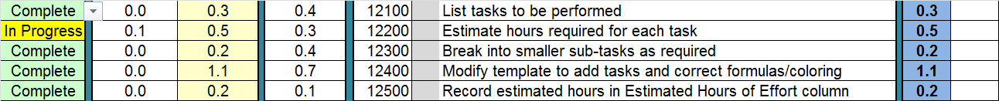

**Figure 3 – typical WBS at end of first week.**

In **Figure 3**, task *12100* was estimated to take 0.4 hours but was completed in 0.3 hours. Task *12200* was estimated to take 0.3 hours but you spent 0.5 hours on it and the task is still not complete – you believe it will require another 0.1 hours. The remaining three tasks are all complete, but in each case your estimated hours are not the same as the actual number of hours required.

The two **Actual Results** columns work together. The one with the white background is the “**Estimated Hours Remaining**” and the one with the yellow background is the “**Actual Hours So Far**”. Initially, before you have started working on the task, the “**Estimated Hours Remaining**” should be set equal to the “**Estimated Hours of Effort**” and the “**Actual Hours So Far**” should automatically calculate to 0. As you work on a task, at the end of each week, you should record the hours worked in the **“Actual Hours Worked and Earned**” section of the PWBS (right hand area with light blue headings). This will cause the indicated cell to change color, as shown above, and will automatically update the number in the yellow “**Actual Hours So Far**” column with the number of hours you have worked on the task. The number in the “**Estimated Hours Remaining**” column has a white background, which means that *you are expected to update this cell by hand each week*. It should be replaced with the number of hours you think are remaining to complete the task. For example [see the second line above, the one that says “*In Progress*”], if you spend 0.5 hours on a task, you record 0.5 in the “**Actual Hours Worked and Earned”** worked area and this will automatically add 0.5 to the “**Actual Hours So Far**” column. If you think there are 0.1 hours left, put 0.1 in the “**Estimated Hours Remaining**” column. [It is no longer necessary that you match the originally estimated hours from your first estimate. One of the purposes of this tracking system is to show how your actual results compare with your original estimate and, thus, where your original estimate was inaccurate. The “**Estimated Hours Remaining**” should always represent your best current estimate of the amount of time left to complete the work.]

Suppose you turn in assignment 1 at the end of week 1. Then, at a minimum, there should be numbers in most of the rows for the assignment 1 tasks for week 1 and most of those should have a status of “*Complete*”, with “**Estimated Hours Remaining**” of 0. All of the remaining tasks (the ones you have not yet started, such as the tasks for later versions of the PWBS or for assignments 2, 3, and 4) should have an “**Estimated Hours Remaining**” equal to the “**Estimated Hours of Effort**” because you have not yet started working on those tasks. If you have started working on some of these other tasks but have not completed them, there should have a positive number in the “**Actual Hours Worked**” column and a positive number in the “**Estimated Hours Remaining**” column, and the **Status** should be “*In Progress*”.

The total of the “**Estimated Hours Remaining**” column (near the bottom left of the spreadsheet) should change each week, as you work on various tasks. **At the end of each week you must copy the total “Estimated Hours Remaining” (from the bottom of the WBS sheet) over to that week’s column** in the **“Actual Hours Worked and Earned”** section of the PWBS. See the discussion of the **Actual Hours Worked and Earned** section, below, in step **d**.

The final thing to do for step c is to record the **Hours Earned** each week of the course. See **Step e** (below) for details on how to do that.

**Step** **d**: **Actual Hours Worked and Earned.**



The right hand side of the **PWBS** sheet consists of a column for each week of the course, followed by a blank column (“insert new column here”), and a “**Total Hours Worked**” column at the far right. **Total Hours Worked** is the total of all hours worked on each task. Each week, you record the actual hours worked on each task in the corresponding column and row of the sheet. The totals are automatically updated. (Study the formulas to see how this happens. This might be on an exam!)

Here is a summary of the remaining parts of these sheets and what you must do with them.

**Rows at the Top**



**Top Row: Planned Effort**. Once you have determined how many hours you will spend on each task, which is recorded in the “**Estimated Hours of Effort**” column, this row will reflect when you should do all that work. In other words, how many hours you should spend on the course assignments each week (on average). The formula in this row assumes you will do the same amount of work each week. So it takes the total in the “**Estimated Hours of Effort**” column and divides by the number of weeks in the course. The template is set up to do this automatically and you may simply leave it alone, although you should look at the formula and understand how it works. You may also choose to adjust things up or down in certain weeks. For example, if you plan to spend less time during some weeks and more in other weeks, you might reduce or increase the **Planned Effort** numbers in those weeks. If you do this, make sure things add up to the correct total. If you do it correctly, the total in the far right of the **Planned Effort** row will match the total hours at the bottom of the **Estimated Hours of Effort** column. {There are more accurate ways of computing **Planned Effort** but they require a lot more work and add very little value to this method of tracking progress.}

**Second Row: Cumulative Plan** or **Planned Value (PV).** This is simply the cumulative total of the **Planned Effort** row. It is computed automatically and the total in the rightmost week’s position should match the total in the far right of the **Planned Effort** row. Note: the **Cumulative Plan** is very important. On the **Burn Up Chart** and the **Earned Value Chart**, the *Plan* line is simply a graph of this row.

**Third Row: Estimated Effort Remaining.** This shows the estimated number of hours of work that remain each week in order to finish all tasks, assuming you follow your plan exactly. In other words, it’s your original estimate of effort remaining. This is also calculated automatically from the first two rows (look at the formula in the template to see the calculation). This row becomes the *Plan* line on the **Burn Down Chart**.

Taken together, the first three rows of the sheet and the task and estimate information in the **WBS** constitute your plan. They show the work you plan to do and the amount of effort you plan to spend on that work each week. These rows will normally remain constant throughout the course, once you have completed your initial estimate (steps a and b) and made any corrections based on comments from the grader or instructor.

**Rows at the bottom**



**Figure 4 – Rows at the bottom of the WBS worksheet.**

To discuss this section of the WBS, we will stard by discussing the section in the middle.

**Total Actual Hours Worked**: This is the sum total of all rows in the **Actual Hours Worked and Earned** portion of the worksheet. This value shows, each week, how many hours you actually worked on the various tasks. It is calculated automatically, provided you enter the hours correctly. Note that if you compare this number with the corresponding number at the top (**Planned Effort**), you can tell how your actual work compares with your original plan. It is not necessary that these numbers match exactly, but if you are consistently doing less work than your plan, it may indicate that you are not keeping up.

**Cumulative Actual Hours** or **Actual Cost (AC):** This is simply the cumulative total of the **Total Actual Hours Worked**, and is computed automatically. It shows the total amount of work you have spent on the tasks since the beginning of the semester. You should not normally have to adjust this formula. This number is displayed on the earned value graph.

**Estimated Hours Remaining:** *This is shown in red as a reminder that you must enter the data for this row at the end of each week*. This number is obtained by copying the number from the total of the **Estimated Hours Remaining** column (at the bottom left of the **PWBS** sheet). You must do this each week at the end of the week, as described above and below. If you fail to do this, it may mess up your graphs. **Special note: copy and then paste the “*value*” of the number. Otherwise, Excel will paste a formula, and that would give you the wrong number. See the “paste special” option under the *Paste* function.**

**Step e: Earned Hours (Tracking Progress).** You need to do the following steps each week of the course. If you skip a week it will be harder to get the numbers correct.

By the time you have completed steps a-d, you will have finished constructing the **PWBS** workbook and, thus, you have a plan. Now it’s time to start using the workbook to track your progress against that plan. This involves several steps. The instructions below are to be followed at the end of each week.

**1 Hours Worked:** Record all hours worked for the week in the “**Actual Hours Worked and Earned**” area and update the “**Estimated Hours Remaining**” for each task. If you have completed a task, you should set the “**Estimated Hours Remaining**” to 0. When that happens, the row for that task will be flagged as “*complete*”. All tasks you have started on but not completed will have positive numbers in “**Estimated Hours Remaining**” and will be flagged as “*in progress*”. For example, when you get to the end of week 1, fill in hours spent during week 1. You only need to do this for tasks you have actually worked on in week 1. Notice that the total hours worked for each task is shown in the rightmost column. So, for example, if you worked on a task for 1 hour in week 1 and 3 hours in week 2, the “**Total Hours Worked**” on the far right will show 4 hours at the end of week 2. This number will also appear in “**Actual Hours So Far**”.

**2 Estimated Hours Remaining:** Copy the “**Total Estimated Hours Remaining**” from the bottom left of the PWBS and paste it (as a *value* – “paste special” / “value”) into the “**Estimated Hours Remaining**”row for the current week. This number will appear on the burn down chart for the corresponding week. *You must update this every week or the burn charts will be inaccurate.*

**3 Earned value:** Earned value is a record of how much work you have actually completed.You can tell if you completed a task this week as follows:

* Look down the column for the current week and note all tasks you worked on.
* For each task you worked on, look to the left and see if the estimated hours remaining is 0 (in which case, the status should be *Complete*).
* If you did not complete any tasks this week, you do not need to do anything about the earned value. You did not “earn” anything this week (you may have worked hard but you didn’t finish anything).
* If you *did* complete some tasks, you have earned the value of those tasks. Do the following for each completed task: find the row for the task you have completed and write down the “**Estimated Hours of Effort**” for that task. Add up all of the estimated hours for all tasks you completed this week and enter the total in this week’s column in the row “**Hours Earned This Week**”.



That’s all you need to do, but you must do it each week. The earned value (EV) portion of the *earned value graph* is produced from the “**Cumulative Hours Earned**”row, which is the cumulative total of the “**Hours Earned This Week**” row.

You will notice that the template has two rows below “**Cumulated Hours Earned (EV)**”. These are labeled “**CPI**” and “**SPI**” and are computed automatically once you have entered the hours earned correctly. The meaning of these will be discussed during the class lectures.

**General note about the above:** It will be worth your time to figure out how each part of the spreadsheet works, how each line on each graph is calculated, how each formula works, etc. Spreadsheets like this are an important tool for any professional software developer, especially team leaders, and an essential tool for anyone doing software metrics. The midterm and final exam may contain questions about different parts of the PWBS spreadsheet!

**New Tasks and Inaccurate Estimates.** As you proceed through the semester, you are likely to learn two things: a) that you underestimated or overestimated the work required to perform some tasks; b) that you overlooked some of the work and need to add new work tasks. That’s OK – these kinds of changes are expected on any project, especially medium to large sized projects. One advantage of a tool like the PWBS is that you can easily see where your estimates were inaccurate and take appropriate action.

1. **Incorrect Estimates.** Incorrect estimates are expected and the PWBS is designed to deal with them. On any real software development project, many estimates will be inaccurate. Although you want to be accurate when making estimates, it is even more important to keep track of your inaccurate estimates and to know how inaccurate they are. This is the purpose of the “**Estimated Hours Remaining**” column and row. Always record the actual hours spent each week and update the “**Estimated Hours Remaining**” each week with your best available information. When you do this, the *burn down chart* will show you how you are doing relative to your plan. Once you have completed the task, the difference between the **“Estimated Hours of Effort”** and the **“Actual Hours So Far”** tells you how accurate (or inaccurate) your original estimate was, for that work task. This serves two purposes:
   1. It helps you estimate similar work tasks more accurately on your next project.
   2. It helps you determine if your project is running ahead of or behind schedule and allows you to make appropriate adjustments in your work plan. For example, if you determine that you are running behind schedule on most tasks, it tells you that you need to allocate more time to get the rest of the work done by the project deadline.

Note that when the PWBS is graded, you will not lose any points for inaccurate estimates unless it is apparent that you did not make a serious attempt at estimating. We expect you to have some inaccurate estimates (but we expect them to be honest estimates). You will be graded on whether you make serious attempts to estimate correctly and whether you track what really happens properly.

1. **New Tasks.** If you decide you must perform a new, unplanned work task, insert it as a new row in the **WBS** worksheet. Indicate an “**Estimated Hours of Effort**” of “0” hours for that new task, but put your real estimate of the hours required in the “**Estimated Hours Remaining**” column. As you work on the new task, record the hours worked each week and update the “**Estimated Hours Remaining**” as well. Note that even when you complete this new task, your “*earned*” hours will be 0. You don’t earn any credit because new tasks are treated as extra work that was not included in your original plan.

Note: When you prepare your plan for the DRAFT PWBS you will have to estimate what tasks you will perform and how long each will take. Since you have not taken this course before, you will probably be inaccurate with some of the tasks. You will NOT be graded on accuracy of your estimate, provided you have made a serious and honest attempt to estimate. You will be graded on completing the worksheet properly to represent your estimate and, later, recording your actual results correctly. I expect some of your “actual” numbers to differ from your estimates and I won’t be surprised to see a few new tasks added to some worksheets. That’s part of the technique!

On the other hand, this does not mean I expect you to estimate poorly in the first week and then make up for the inaccurate estimate by adding new tasks every week. I expect a good-faith effort to estimate correctly. You have enough information available to do so. (It’s also a lot more work and more likely to generate errors if you update the PWBS with new tasks each week.)

## Graphs (Charts)

There are five charts (or graphs) shown on their respective tabs of the workbook – a burn down chart, a burn up chart and three earned value charts.

**Burn down chart**: This chart, which has two thick lines, shows how much work is left to do each week. The thick black line (derived from the “**Estimated Effort Remaining**” row near the *top* of the WBS worksheet) shows the original plan. The thick red line (from the “**Estimated Hours Remaining**”row at the *bottom* of the WBS worksheet) shows what is actually happening. A burndown chart is a very simple way to show the progress of your project and to estimate how much longer it is going to take. Burndown charts are widely used in agile development projects and other adaptive and iterative developments as well as on smaller projects using non-agile techniques. They are relatively easy to construct and they give a good perspective on the status of the project.

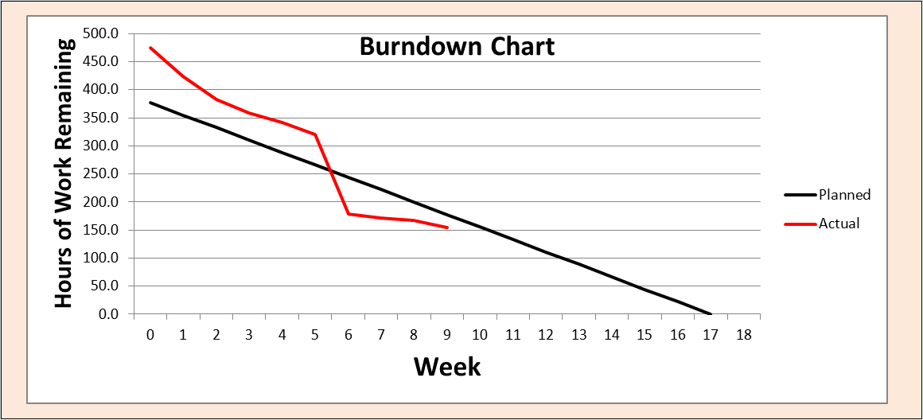

In the above burn down chart, the project was somewhat behind for the first five weeks, but suddenly got caught up in week 6. This may be due to a change in the scope of some of the work tasks or it could be the result of an extraordinary effort on the part of the software developers in week 6.

**Burn up chart**: This chart, which also has two thick lines, also shows how much work is left to do each week. The thick black line (derived from the “**Cumulative Plan**” row near the *top* of the sheet) shows the original plan – how much work you planned to complete each week. The thick red line (from the “**Cumulative Actual Hours**” row at the *bottom* of the sheet) shows what is actually happening. A burnup chart is another simple way to show the progress of your project and to estimate about how much longer it is going to take. Burnup charts are also widely used in agile development projects and other adaptive and iterative developments as well as on smaller projects because they are relatively easy to construct and they give a good perspective on the status of the project. They are considered more helpful than burn down charts at helping you estimate how much extra work you have to do before you finish.

You can judge for yourself whether you find the burnup or burndown chart more helpful. There will be some discussion of these charts in the class lectures.

In the burnup chart shown below, the project started off (ahead of plan) but slowed down and is now slightly behind schedule. (The horizontal line for the **Actual** value simply indicates that if no more work is done, this is as far as the project will be at the end.)

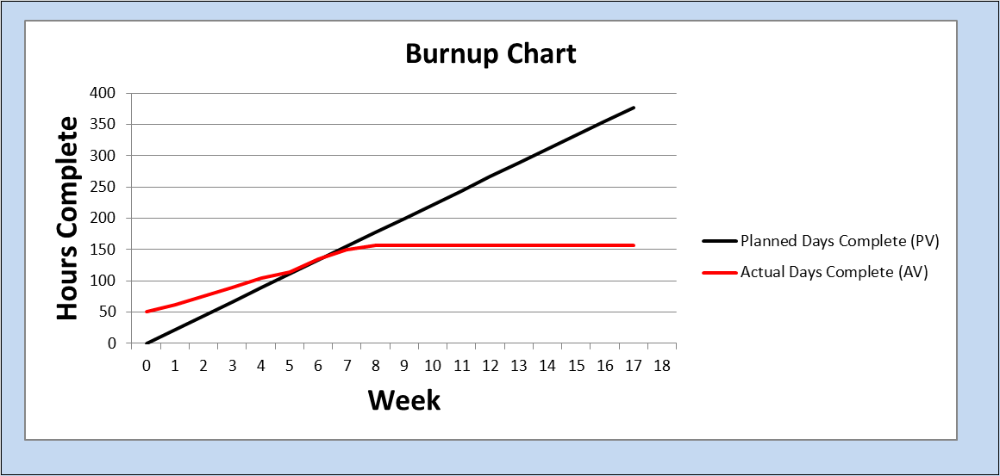

**Earned Value charts:** These charts will be easier to understand after the earned value technique is discussed in the class lectures. The first chart, a form of burn up chart, is a bit more sophisticated than the simple burnup chart, and is commonly used on very large projects. The earned value line chart has three lines:

The thick black line is **PV** or **Cumulative Plan**, recorded each week (i.e., the cumulative total of the “plan” values from week 1 up through the current week). This is derived from the “**Cumulative Plan**” row at the *top* of the worksheet. It represents your plan for completing the work on the project and is identical to the plan line on the burnup chart.

The thick red line is **AC** or **Actual Cost**, recorded each week (i.e., the cumulative total of the “actual” values from week 1 up through the current week). This is derived from the “**Cumulative Actual Hours**” row near the *bottom* of the worksheet. It is identical to the **actual** line on the burnup chart. It shows what amount of effort (work) has actually been performed, but does not say how much of the work is complete.

The thick green line is the **EV** (Cumulative Earned Value), recorded each week (i.e., the cumulative total of the “earned” values from week 1 up through the current week). This is derived from the “**Cumulative Hours Earned**”row at the *bottom* of the worksheet. This line shows how much work has been completed or earned. The amount of credit given for an “earned” task is the *original estimate*, regardless of whether the actual hours spent on the task is larger or smaller than this amount. This is a valuable thing to measure because it helps you judge, on an overall basis, whether you have over- or under-estimated the amount of work required to do the project.

On an ideal project, all three lines on the earned value graph would be the same. But no project is ever ideal. As you proceed through the semester you might want to watch all of the graphs and it would be a good idea to examine them closely to see how they are constructed.

Here is a sample of what an earned value graph would look like:



The above graph shows an eleven week project at the end of week 8. The graph suggests the project had a highly ambitious plan (black line) but has only been able to spend about half as much effort as planned (red line). To their credit, they have accomplished (green line) approximately as much work as their level of effort suggests, meaning that they estimated reasonably accurately, but did not have enough people (or spend enough time) on the project. If this graph represented a student’s PWBS it would indicate a student who estimated the tasks accurately but was not spending enough time on the course assignments.

**Performance Indices (SPI and CPI)**

The two remaining graphs in the earned value section are the SPI and CPI charts. SPI is Schedule Pereformance and CPI is Cost Performance. These will be discussed in the class lectures, but if you look them over you will probably get a good idea of what they are telling you. The black “goal” line is where you want to be. The other line is where you actually are. If the “where you are” line is above the black line you are ahead of schedule or under budget (i.e., things are going well). If the “where you are” line is below the black like, you are behind schedule or over budget (i.e., things are not going well).

**\*\*\*\* Note on grading of the PWBS \*\*\*\***

The PWBS (assignment 1) will be evaluated with feedback to you at the end of week 1. The evaluation will not affect your grade. However, you should heed what you are told and make any corresponding corrections or changes to your PWBS.

It will be graded at the end of week 3 (interim) and again at the end of the course (final). The grading will be based on how seriously you have planned the course and tracked your progress. Here are some of the things that will result in points taken off of your assignment:

* Not having enough tasks and subtasks (in other words, not providing enough detail to constitute a serious plan)
* Not using a hierarchy of tasks where it makes sense to do so
* Having unrealistic estimates of the hours required for each task (for example, making them all exactly 2 hours)
* Failure to record the actual hours each week
* Failure to record the earned hours each week or failure to record the earned hours properly
* Failure to record/update the “estimated hours remaining” for tasks you work on each week
* Failure to copy the “estimated hours remaining” to the appropriate place at the end of each week
* Charts (graphs) make no sense because you did not record the correct information each week
* Totals don’t make sense (this usually happens because you modified formulas incorrectly or you failed to record hours correctly or you inserted new task rows but did not use the correct formulas)

#### Appendix B

#### Alternative WBS Task Numbering Approaches

#### In a work breakdown structure, the task number is a way to show three things:

#### A unique identification number for each task

#### The order of the tasks

#### The hierarchy of the tasks (i.e., which tasks are sub-tasks of others)

#### Two of the most commonly used WBS task numbering systems are shown below:

|  |  |  |  |
| --- | --- | --- | --- |
| System | Example | Advantages | Disadvantages |
| Dot for each level of hierarchy | 1. Top Level   1.1 First item at second level  1.2 Second item at second level  1.2.1 First item at third level  1.2.2 Second item at third level  1.3 Third item at second level  …  Sometimes these are indented:  1.0 Top Level  1.1 First item at second level  1.2 Second item at second level  1.2.1 First item at third level  1.2.2 Second item at third level  1.3 Third item at second level  … | * Can allow an arbitrary number of levels * Can allow an arbitrary number of tasks at any level * Widely used for large work breakdown structures | * Harder to use for sorting (some sorting tools will not sort these in the proper order) |
| Each Digit corresponds to a level | 100000 Top level item  110000 First item at second level  120000 Second item at second level  121000 First item at third level  122000 Second item at third level  130000 Third item at second level  This can also be indented. *The WBS template uses an indented form of this system.* | * Can be used to sort the tasks into the proper order * Convenient to use for small WBSs | * Allows only ten tasks at any level * Number of levels is limited to the number of digits initially set up (six in the case of the WBS template) |

For purposes of assignment 1, the numbering system you use is not important. So you may use a different one if you wish. You could use the first method (with the dots), but most students will use a variation of the second method. Here are some commonly encountered situations and how you might be able to handle them if you start with the second method:

|  |  |  |
| --- | --- | --- |
| **Problem** | **Suggested Approach** | **Example** |
| You have more than ten tasks at a given level | Use two digits for tasks at that level (you only need to do this for the specific situation where there are more than ten tasks) | 200000 Top level task for assignment 2 201000 First sub-task for assignment 2  202000 Second sub-task for assignment 2  … 215000 Fifteenth sub-task for assignment 2 |
| You have more than ten top level tasks | Use the first two digits for the top level tasks | 010000 Top level task for assignment 1 020000 Top level task for assignment 2  … |
| You have more than six levels | Use extra digits as needed | 10000000 Top level task for assignment 1 …  20000000 Top level task for assignment 2  …  (adding two extra digits allow two extra levels) |

#### [cover sheet – this is a reproduction of the cover sheet found as the leftmost tab in the PWBS template. It is shown here for your information, but you should use the one in the template. Fill in all bold, underlined sections with your specific information.]

ASSIGNMENT 1

1

#### DO INITIAL VERSION OF PERSONAL WBS

**CSE 6329**

**PLANNING AND MANAGING A SOFTWARE PROJECT**

***Fall, 2017***

Professor Dennis J. Frailey

NAME __**<*Your Name Goes Here>***______ STUDENT ID NUMBER _***<id# Goes Here>***_

THIS COVER SHEET SHOULD APPEAR AS THE FIRST PAGE.

Grading template Student do not write inside this box

WBS (100 points) ___________

__________ Correct Format, including name on top, totals, etc. (10 points)

__________ Reasonable list of tasks (50 points)

__________ Reasonable estimates of time for each task (30 points)

__________ Proper recording of actual and earned hours in first week,

including proper updating of estimated hours remaining.

___________/100 Total Assignment Grade

Comments from Grader

*(comments go here)*

Note: if you receive comments on your DRAFT PWBS, make

the indicated corrections and delete the grader comments on

your INTERIM PWBS.

If you receive comments on your INTERIM PWBS, make

the indicated corrections and delete the grader comments on

your FINAL PWBS.